Method-1

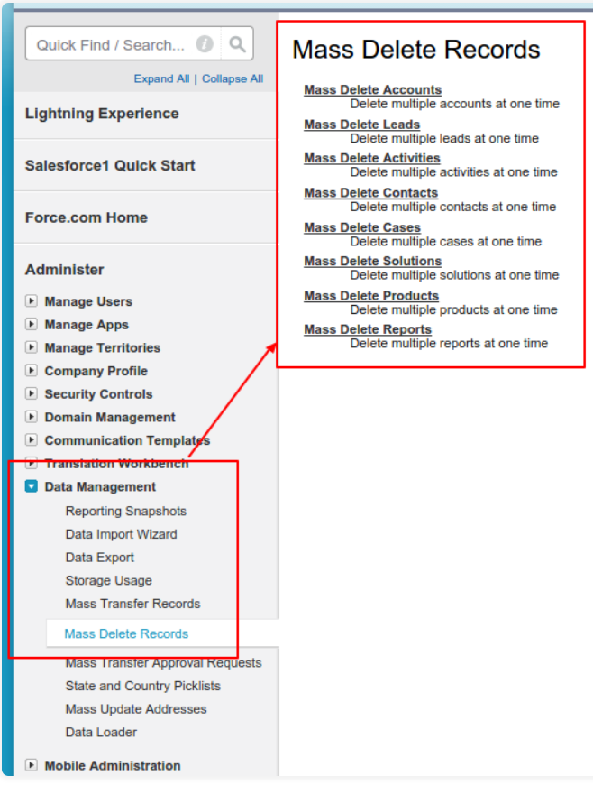

Method-2

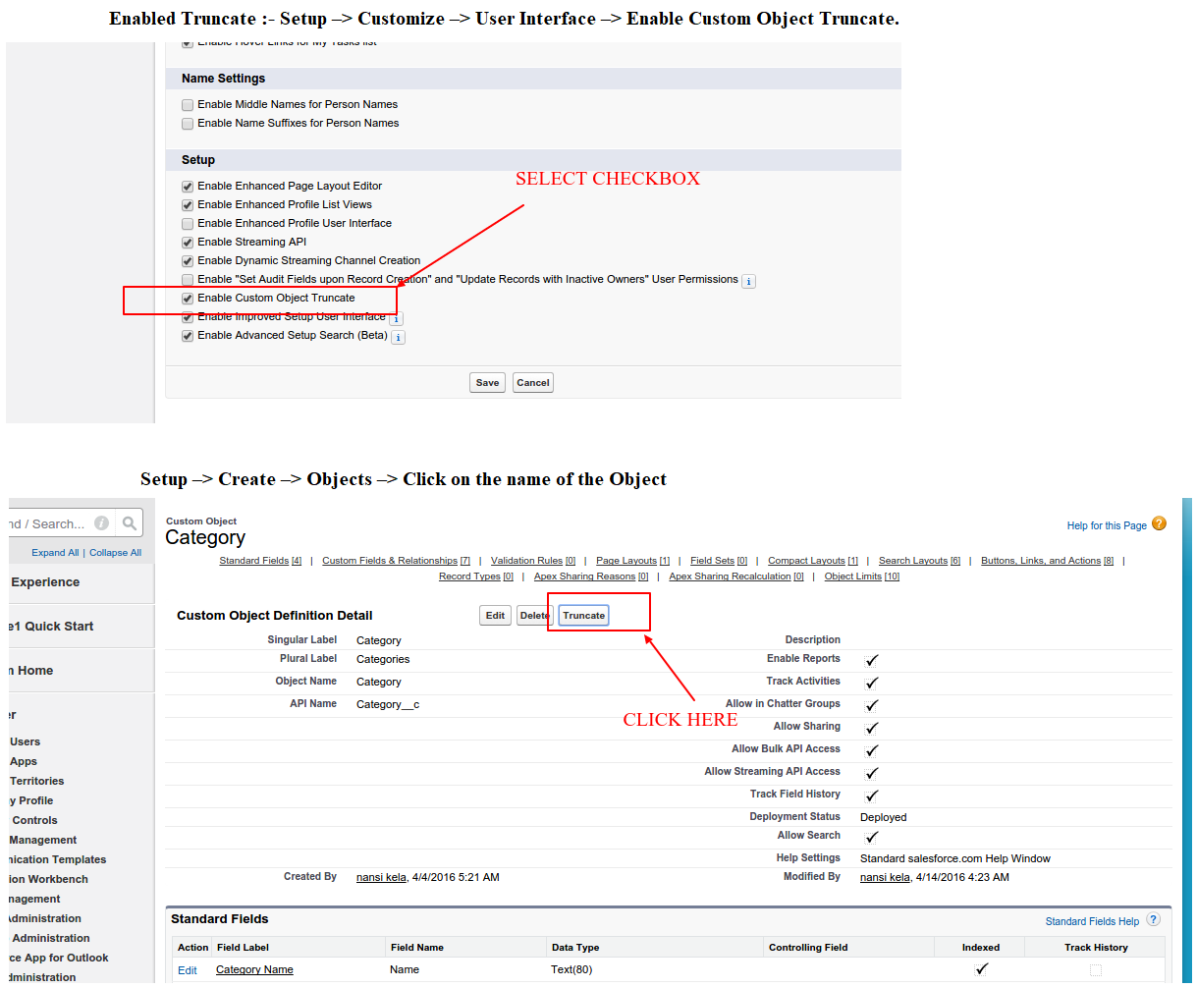

Method-3

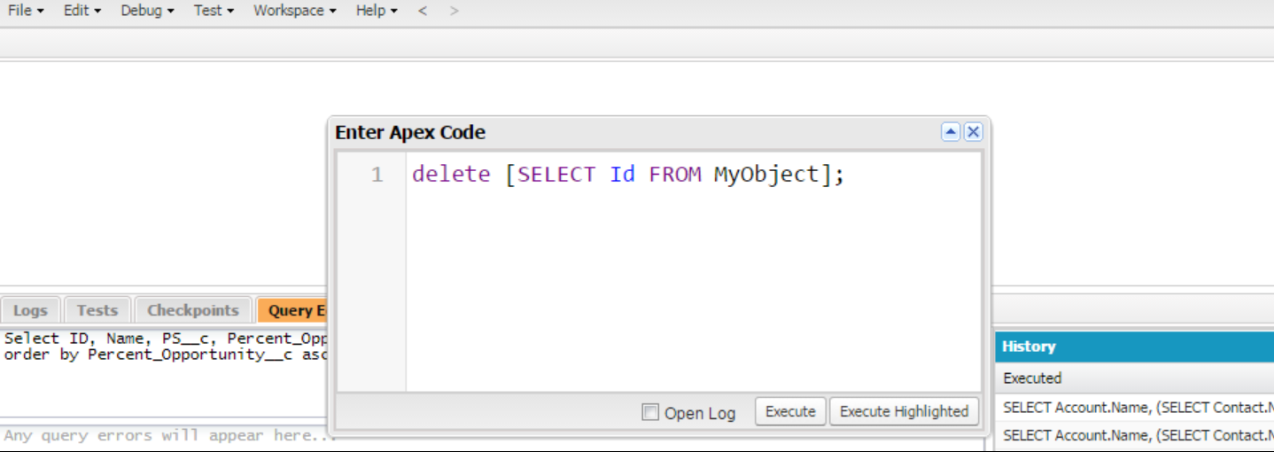

Method-4

Just navigate to the record you want to delete and look for the standard Delete button. Clicking this button will move that record into your ORG's [Recycle Bin](https://help.salesforce.com/apex/HTViewHelpDoc?id=home_delete.htm).  
  
N.B. If you don't see the Delete button you may need to edit the page layout to add it.

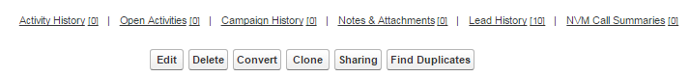

Method-5

**Delete from the List view**  
  
When viewing a list of Accounts, Contacts or Leads etc. you will see a 'Del' link against each record. Clicking on this will send the record to the Recycle Bin.

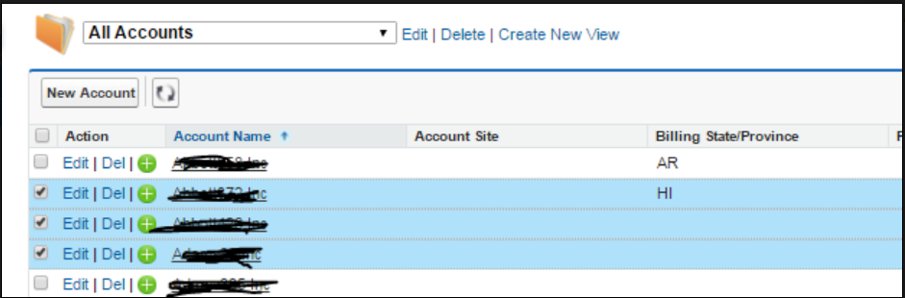

Method-6: Data loader

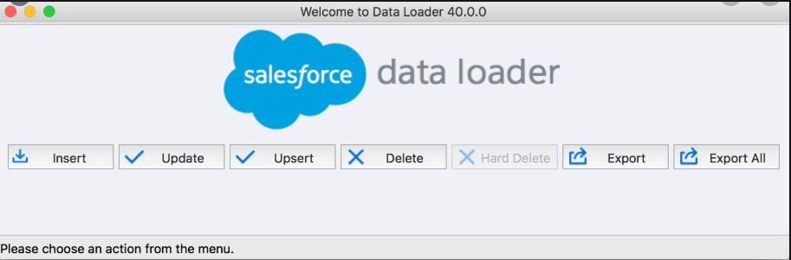

Dataloader.io

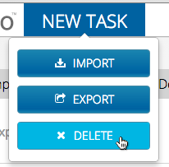

Method-7

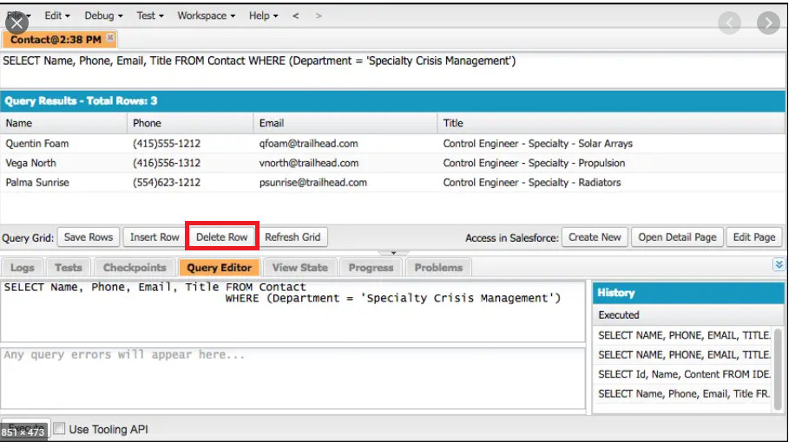

Method-8

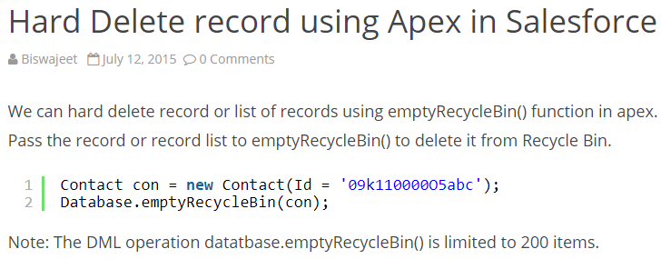

Method-9

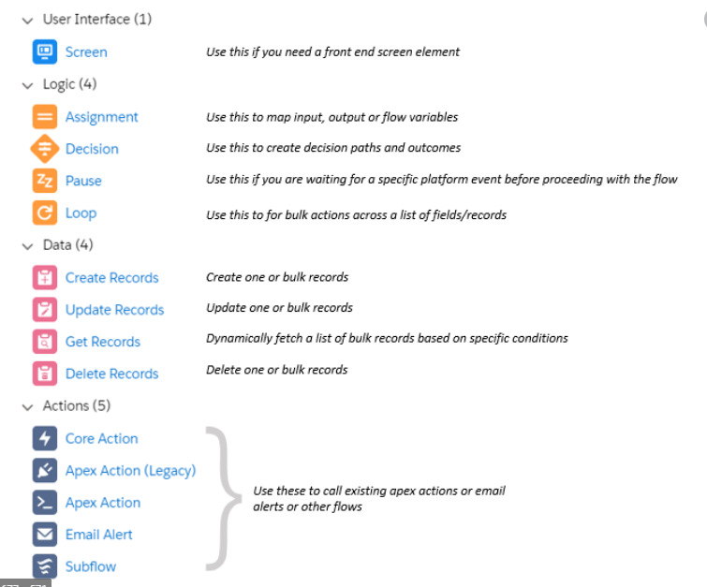

Method-10: Apex Trigger/Apex Class

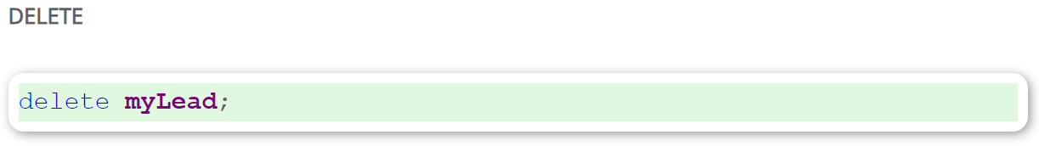

Or

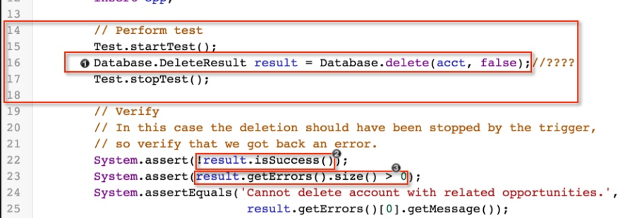

Method-11: Rest API (delete Operation)

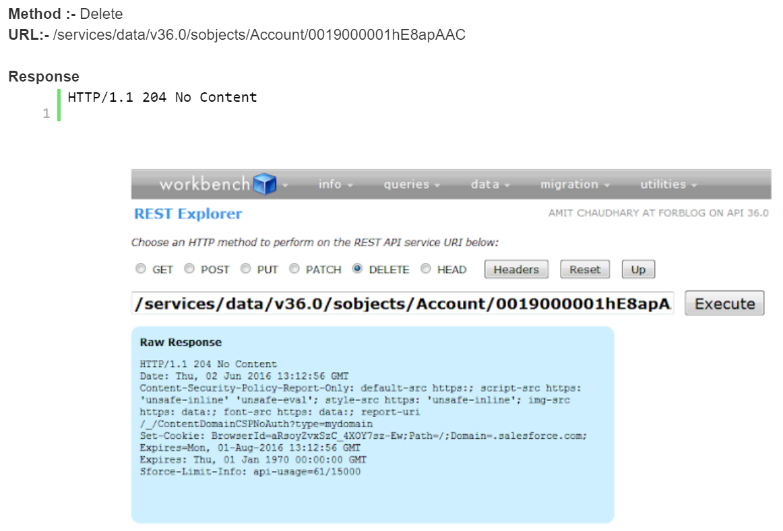

Or

